August 14th, 2011
Hi
Not much to write about.
I did not do any exercise this past week. But still I managed to injure my lower back through just sitting! I think it may be the soft hotel chairs which are not the best for posture. I switched to using my old hard, straight-backed chair, which forces one to sit up straight and is not too uncomfortable. The back is slowly healing.
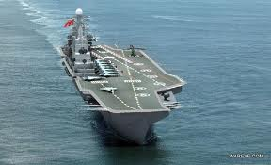
The aircraft carrier USS Ronald Reagan and its support ships are in HK for a few days of R&R. China (and not HK, as China has control over foreign affairs and defence) has to give permission for such visits, and is regarded as a 'barometer' of how relations are between the US and China. This week, China's first aircraft carrier was out for first brief sea trials. The ship was originally a Soviet ship but was incomplete when the Soviet Union fell in 1991 so China bought it. I have mentioned before that there is a similar ship in Shenzhen which was also bought from the Russians and is now a floating museum. In my (one) annual run around the part of HK near the border, I can see the ship.
The government has announced details of the $6000 payout scheme for HK permanent residents. But, at the moment, it seems you will not be able to get the money even though you are entitled to it. There are two ways to get it:
1. Deposited into you own HK bank account. As you (probably) do not have one, this method is out. And you cannot set up a bank account without going to the bank.
2. By cheque. However, the cheque can only be cashed at one particular bank in Hong Kong. It can not be cashed overseas. The cheque is valid for one year but you would have to come back to HK to collect and cash it.
Here is the website which you may like to look at:
http://www.scheme6000.gov.hk/eng/index.html
Talking about websites, it was 20 years ago that the web began. On August 6th, 1991, Tim Berners-Lee, a British physicist at the European Organisation for Nuclear Research (CERN), in Geneva, created the first-ever web page—a summary of his WWW project along with explanations to help visitors build websites of their own and to search the web for information.
The installation of the equipment to upgrade the broadband connection will be done this week, though the increased speed service does not begin until September 1st.
Yesterday, in Durban, the Wallabies beat the springboks 14-9. There was also a big celebration in Melbourne the other day to welcome the first non-European to win the Tour de France cycling race. In a sport beset by drug-taking, this guy seems to be clean.
Last Sunday, the “White Mouse” died aged 98. Her name was Nancy Wake, born in New Zealand, brought up in Australia before going to England and eventually becoming a heroine in the French Resistance, and receiving some of the highest awards for bravery from France, the UK and the US (but not from Australia or NZ, though she did get some recognition from these countries a few years ago). A very interesting story. Here is one website:
http://en.wikipedia.org/wiki/Nancy_Wake
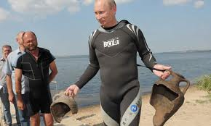
In last year's letter (which I am overwriting), I mentioned one of Putin's 'stunts'. This was of him 'flying' a plane on a water-bombing sortie during the wild fires that raged in Russia a year ago. Well, he has been at it again. This time he went Scuba diving in the Black Sea, in all of 6 feet of water (goodness, you don't need Scuba gear for 6 feet!) and made a 'startling' discovery of two ancient Greek urns, despite the fact that the water was so clear that everybody not in the water could clearly see the urns and despite the fact that in the same place, over the last two years, archaeologists only managed to find only a few pottery shards!

Last year I also commented on a HK milk-tea making competition ('cha chaan teng', made from black tea and evaporated – not condensed - milk) . Well, this year, the competition included a cha chaan teng/coffee mixture competition. I don't know if this brew is new or whether it has been around for some time.
Also, I hope you read the article on eating hot dogs that I e-mailed to you yesterday.
Tomorrow is the anniversary of the end of WWII (in the pacific).
That seems to be all for now.
Cheers

